For this assignment, use Google Image Search to view pictures of the following computer parts:
- RAM
- CD-ROM Drive
- CPU
- Power Supply
Write up what you've learned about these items and submit your response.
1) RAM
Random Access Memory is the most common type of volatile memory that had very fast response time. Any pieces of data in the storage can be retrieved with same response time.
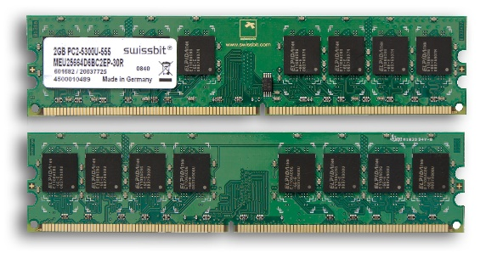

2) CD-ROM Drive
Compact Disk – Read Only Memory Derive (CD-ROM) is a flat plastic disk used to store information. The information cannot be changed but can be accessed by the computers. Examples of CD-ROMs ae computer games.
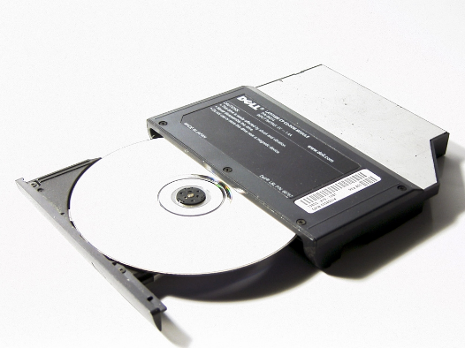
3) CPU
Central Processing Unit (CPU) acts like the brain of the computer that controls every action of the computer. It is a small device with billions of tiny electronic components. CPU only perform one action at a time and can perform billions of actions per second.
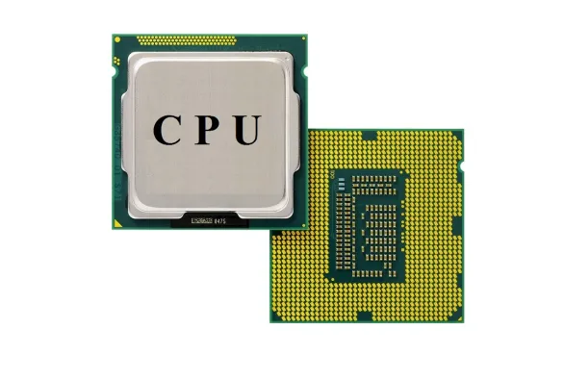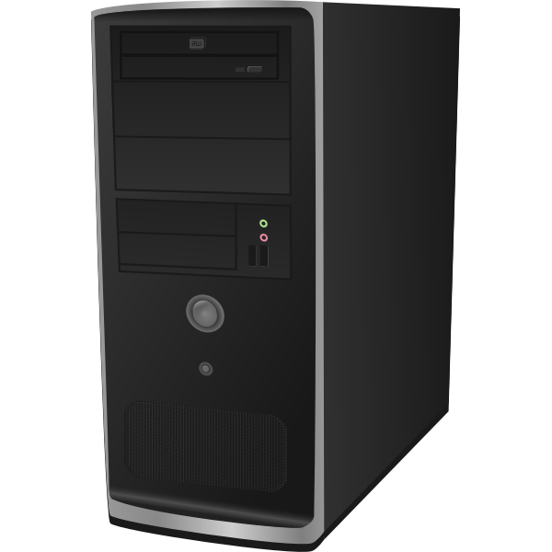
4) Power Supply
Power supply is a machine that receives electric energy to turn on the computer.
